HomePod and IPS build processes
Editable process and specification master • Revision 10 • 15 October 2026
Keep this document as the reference for changes to the two Bob build videos. Amend the relevant numbered step and specification, then record the change on the final page. The sequences are illustrative; final structural and installation details remain project-specific.

HomePod preparation and structure
01 Introduce the HomePod. Bob introduces the build. Show the completed flat-roof concept before the construction sequence.
02 Factory formed openings. Form door and window openings in the factory to the approved panel and opening schedule. Protect panels and exposed cores.
03 Explain the IPS panel. Show 12 mm Sulfrock magnesium sulphate board faces and the 150 mm Plixxent PU insulation core. This gives a 174 mm layer sum, described as 175 mm nominal.
04 Prepare the base. Check the designed base, supports and levels. Coordinate the floor build-up and service entries with the project design.
05 Fit the DPC and sole plate. Lay the specified DPC and fit the sole plate. Check line, level, bearing and anchorage to the approved detail. The panel face boards overlap the sole plate as the panel slots over it; the plate is concealed in the completed wall. Use Tapcon concrete fixings to the Fixings North West and IPS technical detail.
06 Erect the external walls. Position, brace and align the panels. Make panels level and truly upright. Maintain the specified 2 mm joint gaps.
07 Fit splines and bond joints. Fit the IPS spline or specified TR26 timber spline. Both spline types match the height of the rebated Plixxent PU insulation and sit on top of the sole plate. Adhesive-seal the mating joints and splines to the approved fixing schedule. Distinguish the IPS timber spline joint from the IPS panel spline joint. The 98 mm dimension is the total IPS panel spline width shared between the two adjoining panel rebates; it is not a separate width within each panel. The 2 mm gap is between panel edges.
08 Stagger the wall fixings. Recorded pattern: 400 mm down each side, staggered to give 200 mm along the joint. Confirm screw type, length and edge distances for the project. Panel fixings are Rawlplug screws to the Fixings North West and IPS specification and technical detail.
09 Close corners ends and openings. Fit 35 mm TR26 at corners, ends and window and door openings, together with the IPS top-hat detail in Sulfrock, to fully encapsulate the Plixxent PU insulation. Adhesive-seal all joints and top-hat interfaces.
10 Fit the internal panel walls. Install internal walls to the approved layout. Check door positions and service routes. Complete the wall arrangement before the roof.
11 Complete the wall heads. Fit the header plate on top of the rebated Plixxent PU insulation and the timber or IPS splines, which finish at the same height. Fully encapsulate the insulation with Sulfrock boards and the Sulfrock top-hat detail; continuously seal the interfaces. Where additional storeys are included, use the floor junction described in the specification register. Show upper and lower panels with matching 12 mm Sulfrock / 150 mm Plixxent PU insulation / 12 mm Sulfrock sections. The header plate fits within the panel head rebate between the face boards and is concealed in the completed assembly.
12 Prepare the roof strips. Current concept: 600 mm strips cut from 1200 mm-wide panels, with a proposed 45 mm PU rebate for splines. The video shows 175 mm nominal roof panels.

HomePod roof finishes and handover
13 Support the roof joints. Panel end joints bear on designed support. Coordinate full panels and infill panels with the approved layout; verify beams, bearings, splines and overhangs. Illustrate the panel end joint in section, with a support zone beneath the joint. Do not show an unexplained beam or post across the pod frontage.
14 Install the flat roof panels. Fit and restrain panels in sequence. Keep insulation and air seals continuous. Form the designed fall towards drainage.
15 Weatherproof the roof. Apply the specified Remmers liquid-roofing system. Treat joints, edges, outlets and penetrations. Written confirmation of the roofing test scope is still awaited.
16 Install windows and doors. Fit the specified UPVC windows and doors. Check heads, jambs, sills, drainage and weatherproof closures. Use 35 mm TR26 and the IPS top-hat detail around window and door openings to fully encapsulate the Plixxent PU insulation.
17 Seal the openings. Use SIGA Fentrim at the internal window air seal and the specified SIGA external sealant detail. Seal interfaces and service penetrations.
18 Prepare external joints. Apply Terrix RNLF8 filler with fibre scrim to the accepted external joint detail. Treat the recorded 2 mm gaps within the selected Sulfrock and Terrix system.
19 Apply the Terrix render finish. Sequence: AD-AB base coat and mesh; specified beads including the 10 mm stop bead; PR-PS-R primer; RD-PS-S render. Confirm the complete build-up.
20 Apply an alternative external finish. Terrix brick slips or a specified batten and timber-cladding system are alternatives. Use the matching carrier and fixing system; coordinate openings, edges and ventilation.
21 Fit battens and service void. Fit wall and ceiling battens as specified. The current concept proposes 45 × 45 mm ceiling battens. Maintain the designed air and vapour layer.
22 First fix services. Route electrical and plumbing services in the planned void. Inspect and seal penetrations before closing the linings.
23 Fit plasterboard and treat internal joints. Fit the specified plasterboard lining. The recorded internal joint product is Terrix RNLF5 with scrim, to accepted joint details. Confirm layer count and fixings.
24 Apply internal plaster and paint. Apply Terrix PL-SX spray plaster, followed by Terrix IP-ST-P internal paint. Prepare and dry each layer as specified.
25 Complete the fit out. Fit the kitchen, bathroom, storage and finishes required by the selected layout. Test services and complete snagging.
26 Inspect and hand over. Record concealed work and final inspections. Confirm the project structure, roof and assembly evidence before handover.
HomePod uses: individual accommodation for women moving on from refuge and people experiencing homelessness; garden rooms; home offices; and a building for older relatives at the family home. Village Pathway remains a separate linked option.

IPS house base walls and roof
The direct IPS video starts with the house-build sequence: ground floor, first floor, roof, weatherproofing, external finishes and internal fit-out. Spline and plate section details show the corrected bearing arrangement.
01 Prepare the base and DPC. Check the designed slab and set out the walls. Lay continuous DPC below the timber sole plate.
02 Fix the timber sole plate. Set and fix the sole plate over the DPC to the engineered fixing detail. Use specified Tapcon concrete fixings for sole and wall plates where anchored to concrete; use the designed connection for other substrates.
03 Erect the first wall panels. Slot the panels over the sole plate so the face boards overlap and conceal it. Timber and IPS splines match the height of the rebated Plixxent PU insulation and sit on top of the sole plate. Install the specified adhesive seals. Keep the panels level and truly upright.
04 Fix the panel joints. Maintain 2 mm panel joint gaps. Fix board faces to splines using the recorded 400 mm spacing on each edge, staggered to give 200 mm along the joint. Panel fixings are Rawlplug screws to the Fixings North West and IPS specification and technical detail.
05 Form the corner and return wall. Install the specified corner timber spline and continue the next row of panels.
06 Complete ground floor walls and openings. Place panels to the opening schedule. Complete the ground-floor perimeter, with temporary stability and bracing to the project design.
07 Fit the ground floor header plate. Fit the timber header plate on top of the rebated Plixxent PU insulation and the timber or IPS splines around the completed wall perimeter. The insulation and splines finish at the same height beneath the header plate. The header plate fits within the panel head rebate between the face boards and is concealed in the completed assembly.
08 Close corners ends openings and wall heads. Fit 35 mm TR26 at corners, ends and window and door openings with the IPS top-hat detail in Sulfrock to fully encapsulate the Plixxent PU insulation. Bond and seal the interfaces. Complete wall-head encapsulation with the specified Sulfrock boards and top-hat detail.
09 Install joist hangers and floor joists. Position the joist hangers so they hook over the Sulfrock top-hat detail. The recorded hanger spacing is 400 mm centres. Set the hangers, joists, fixings and restraint to the engineered project detail. Show a clear length of timber joist seated inside its metal hanger, with the joist upper face reaching the underside of the flooring without a gap. Keep the hanger seat and hook clearly visible.
10 Lay the first floor deck. Flooring options: 18 mm Sulfrock tongue-and-groove (T&G) flooring or 22 mm chipboard flooring. Run the selected decking continuously to the outside face of the building, including beneath the external wall panels. Repeat this arrangement at every subsequent floor level. Confirm the selected product, span and fixing schedule for the project.
11 Fit the first floor sole plate. Fix the next-storey sole plate through the floor decking into the header plate below. Repeat at every subsequent floor level. Specify screw type, length, spacing and required penetration in the project fixing schedule.
12 Erect the first floor wall panels. Repeat the ground-floor arrangement: timber and IPS splines match the height of the rebated Plixxent PU insulation and sit on the first-floor sole plate. Slot the panels over the sole plate so the face boards overlap and conceal it, then fix and brace. Complete the openings and wall perimeter.
13 Fit the upper header plates hangers and joists. Fit upper header plates on top of the insulation and splines, which finish at the same height. Fit hangers and joists to the approved design. At each further floor level, repeat the full-width deck, sole-plate fixing and Sulfrock encapsulation arrangement.
14 Install and brace roof trusses. Place and restrain roof trusses to the truss designer’s layout. Complete permanent bracing and the specified roof build-up.

IPS house finishes and completion
15 Complete the tiled roof. Fit the specified roof layers, battens and tiles over the engineered trusses.
16 Install windows and doors. Fit the ground-floor and first-floor windows and the external door units. Complete perimeter seals to the specification. Use 35 mm TR26 and the IPS top-hat detail around window and door openings to fully encapsulate the Plixxent PU insulation.
17 Seal the window interfaces. Apply SIGA Fentrim at the internal window-to-substrate connection. Complete the specified external weather seal.
18 Review the external finish materials. Place the Terrix materials information here, before joint preparation and finishing. The external joint filler is RNLF8. Confirm the complete brick-slip system and its primer, adhesive and grout codes.
19 Prepare external panel joints. Apply Terrix RNLF8 joint filler and fibre scrim to the specified joint detail before the base coat.
20 Apply base coat mesh and beads. Apply Terrix AD-AB to the specified substrate with the selected mesh. Fit window beads and the 10 mm stop bead at the bottom perimeter.
21 Install the selected external finish. The house video shows the Terrix red multi brick-slip finish. Use the approved substrate, adhesive, movement joints and weather details. Render is an alternative specification, not an extra layer over brick slips.
22 Fit internal battens. Form the internal service zone with the specified battens.
23 First fix electrical and plumbing services. Route services within the planned service zone and complete the required inspections before lining.
24 Fix plasterboard. Fix the specified lining over the completed service runs.
25 Treat internal joints. Use the accepted internal joint detail, including Terrix RNLF5 and mesh scrim where specified.
26 Apply internal spray plaster. Apply Terrix PL-SX over the prepared internal wall surface.
27 Apply internal paint. Apply Terrix IP-ST-P to the prepared and dried internal finish.
28 Complete fit out and handover. Finish the accommodation, test services and complete snagging and project sign-off. The closing animation shows landscaping, moving in and the finished home.
Video presentation: retain the slower build-stage pace, captions and normal-speed music. The direct IPS video omits the long static introduction; HomePod has a three-second opening. Show equal spline and rebated-insulation heights throughout the construction scenes. Show both flooring options, the deck continuing to the outside face, and the next sole plate fixed through the decking into the header below. Label additional-storey details as applicable to the design. Fire resistance assessment of the complete junction remains in progress. Sole and header plates are concealed by the overlapping panel faces. Exposed timber is shown for illustration purposes only. Show the 2 mm gap at the panel joint, never as a sole-plate gap.

Specification register and changes
TR26 sizes approved by Rob on 15 October 2026 supersede older timber dimensions: 47 × 147 mm sole plates and double splines; 35 × 147 mm headers and closures. Retain these sizes unless Rob explicitly changes them. Update corresponding captions and specifications; project-specific design checks still apply.
Item | Current recorded specification
Board faces | 12 mm Sulfrock magnesium sulphate board on each side. Use magnesium sulphate terminology.
Panel widths and lengths | 1200 mm wide; listed lengths 2400, 2700 and 3000 mm.
Nominal panel build ups | 100 / 125 / 150 mm Plixxent PU cores correspond to 125 / 150 / 175 mm nominal panels. Exact layer sums with two 12 mm faces are 124 / 149 / 174 mm.
Recorded spline details | IPS panel spline: 150 × 98 mm. The 98 mm is the total width shared between the two adjoining panel rebates. The 2 mm gap is between the panel edges, not a joint in the sole plate. Timber option: 2 × 147 × 47 mm TR26. Both spline types match the height of the rebated Plixxent PU insulation, sit on top of the sole plate and finish beneath the header plate. Use the specified joint option for the project.
Recorded closure and plates | Corners, ends and window and door openings: 147 × 35 mm TR26 together with the IPS top-hat detail in Sulfrock, fully encapsulating the Plixxent PU insulation. Sole plates: 147 × 47 mm TR26. Header plates: 147 × 35 mm TR26. The header rests on the insulation and splines, which finish at the same height. Final junction dimensions and fixings require project confirmation. Panels slot over the sole and header plates, with the panel faces concealing the timber. Any exposed timber in illustrations is shown for explanation only.
Top hat detail | IPS top-hat: two 12 mm Sulfrock layers bonded with Plixxent adhesive. The 175 mm wide outer cap sits outside and covers the board edges. The centred 151 mm inner section faces into the rebate towards the 35 mm TR26, leaving 12 mm shoulders each side. Total top-hat thickness: 24 mm. Fully encapsulate the insulation at corners, ends and window and door openings; joint all interfaces with adhesive to the specification.
Panel joints and screws | 2 mm panel joint gaps. 400 mm down each edge, staggered to give 200 mm along the joint. Record screw type, length, edge distances and anchorage in the project fixing schedule.
Joint fillers | External: Terrix RNLF8 plus fibre scrim. Internal: Terrix RNLF5 with the accepted scrim detail.
Render and internal finishes | External render: AD-AB, PR-PS-R and RD-PS-S, with specified mesh and beads. Internal: PL-SX spray plaster and IP-ST-P paint.
Items still to be selected | Roof thickness and spans; support and restraint; precise spline and rebate dimensions; sealant; wall and ceiling batten details; lining layers; complete brick-slip system; service specification.
Flooring options | 18 mm Sulfrock tongue-and-groove (T&G) flooring or 22 mm chipboard flooring. Manufacturer certification for the selected 18 mm flooring product has been requested and will be added after verification.
Floor edge and sole plate | At first-floor level and every further floor level, extend decking to the outside face of the building beneath the external wall panels. Fix the next sole plate through the decking into the header plate below, to the project fixing schedule.
Joist hangers | Joist hangers hook over the Sulfrock top-hat detail. Recorded spacing: 400 mm centres; confirm hanger selection, bearing and fixing schedule for the project.
Insulation encapsulation | Fully encapsulate the Plixxent PU insulation below with Sulfrock boards and the Sulfrock top-hat detail. Complete the specified bonded and sealed interfaces.
Junction fire performance | Testing or assessment of the complete wall and floor junction is work in progress. Product reaction-to-fire classification does not establish a fire-resistance rating for the complete junction.

Change record
Date and revision | Process step | Change required
11 October 2026 / Rev 2 | HomePod 07, 11; IPS 03, 07, 12, 13; specification register | Corrected spline height and plate bearing: timber and IPS splines match the rebated insulation height, sit on the sole plate, and support the header plate together with the insulation. Both video section details updated.
11 October 2026 / Rev 3 | HomePod 11; IPS 08, 10, 11, 13; specification register | Flooring options added: 18 mm Sulfrock tongue-and-groove (T&G) flooring or 22 mm chipboard flooring. Deck to outside face at every floor; sole plate fixed through deck into header below. Full Sulfrock and top-hat encapsulation recorded; joist hangers hook over the top-hat detail. Complete-junction fire assessment remains in progress.
11 October 2026 / Rev 4 | IPS spline dimension | IPS spline dimension corrected from 92 mm to 98 mm to allow the required 2 mm gap. Apply to both videos and the specification register.
11 October 2026 / Rev 5 | HomePod 18; IPS 18–19; joint filler specification | External joint filler corrected to Terrix RNLF8 throughout both videos and this master. Internal joint filler remains Terrix RNLF5. HomePod opening reduced to three seconds. Corners, ends and window and door openings: 35 mm TR26 plus IPS top-hat detail to fully encapsulate the insulation.
11 October 2026 / Rev 6 | Top-hat orientation in both videos and specification register | Turned the top-hat detail over: 151 mm narrow section into the rebate; 175 mm cap outside, covering the board edges. Added a close-up section in both videos, stating that joints use adhesive to the specification.
11 October 2026 / Rev 7 | HomePod 11 and 13; IPS floor junctions and joist hanger | Upper and lower panel sections now match: 12 mm Sulfrock / 150 mm Plixxent PU insulation / 12 mm Sulfrock. Timber joist extends to the underside of the flooring and is seated in its metal hanger. HomePod roof support replaced by an end-joint section; unexplained external timber removed. Existing video audio retained.
11 October 2026 / Rev 8 | Panel joints and concealed sole and header plates | Separate IPS timber spline joint and IPS panel spline joint illustrations. IPS panel spline is 98 mm total across both panel rebates. The 2 mm gap belongs at the panel edges. Panels slot over sole and header plates; timber is concealed in the finished assembly and exposed only for illustration. Tapcon concrete plate fixings and Rawlplug panel screws added to both methods, per Fixings North West and IPS technical details.

Panel joint and concealed plate illustrations
The sections distinguish the IPS timber spline joint and IPS panel spline joint. One spline spans both panel rebates. The 2 mm panel joint is between the panel face edges; it does not interrupt the sole plate.
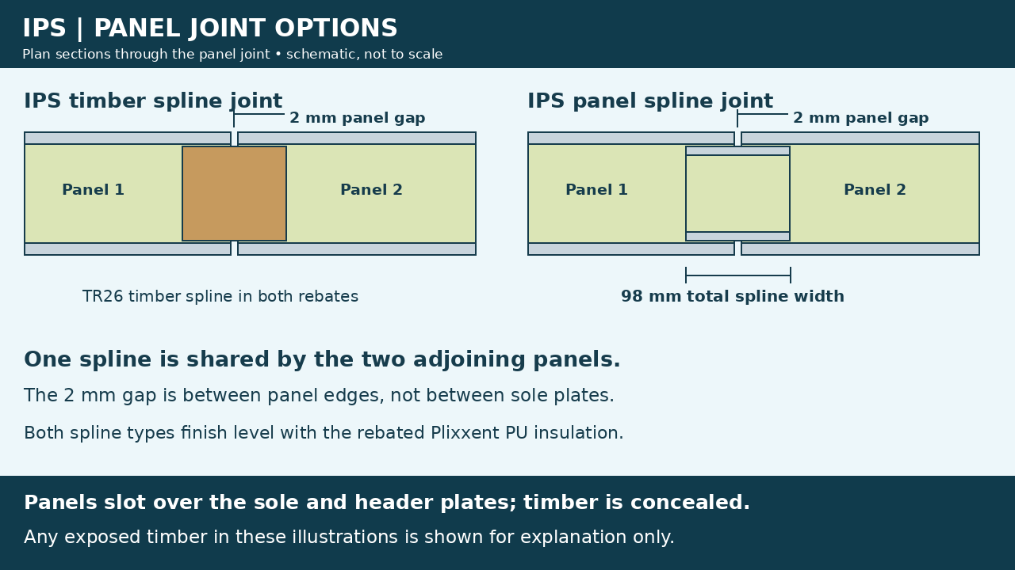
Panels slot over the sole and header plates. The panel faces cover the plates in the completed wall. Timber and IPS splines sit on the sole plate and finish level with the rebated Plixxent PU insulation beneath the header plate. Exposed timber in build illustrations is shown for explanation only.

Approved floor and joist junction
Revision 9 issued 11 October 2026. This detail supersedes previous floor-junction illustrations. The upper panel faces conceal the sole plate; the sole plate bears on the flooring and fixes through the deck into the header below. The joist is seated in its metal hanger and reaches the underside of the flooring. Header and sole plates remain concealed in the finished assembly. The illustration exposes them to explain the arrangement.
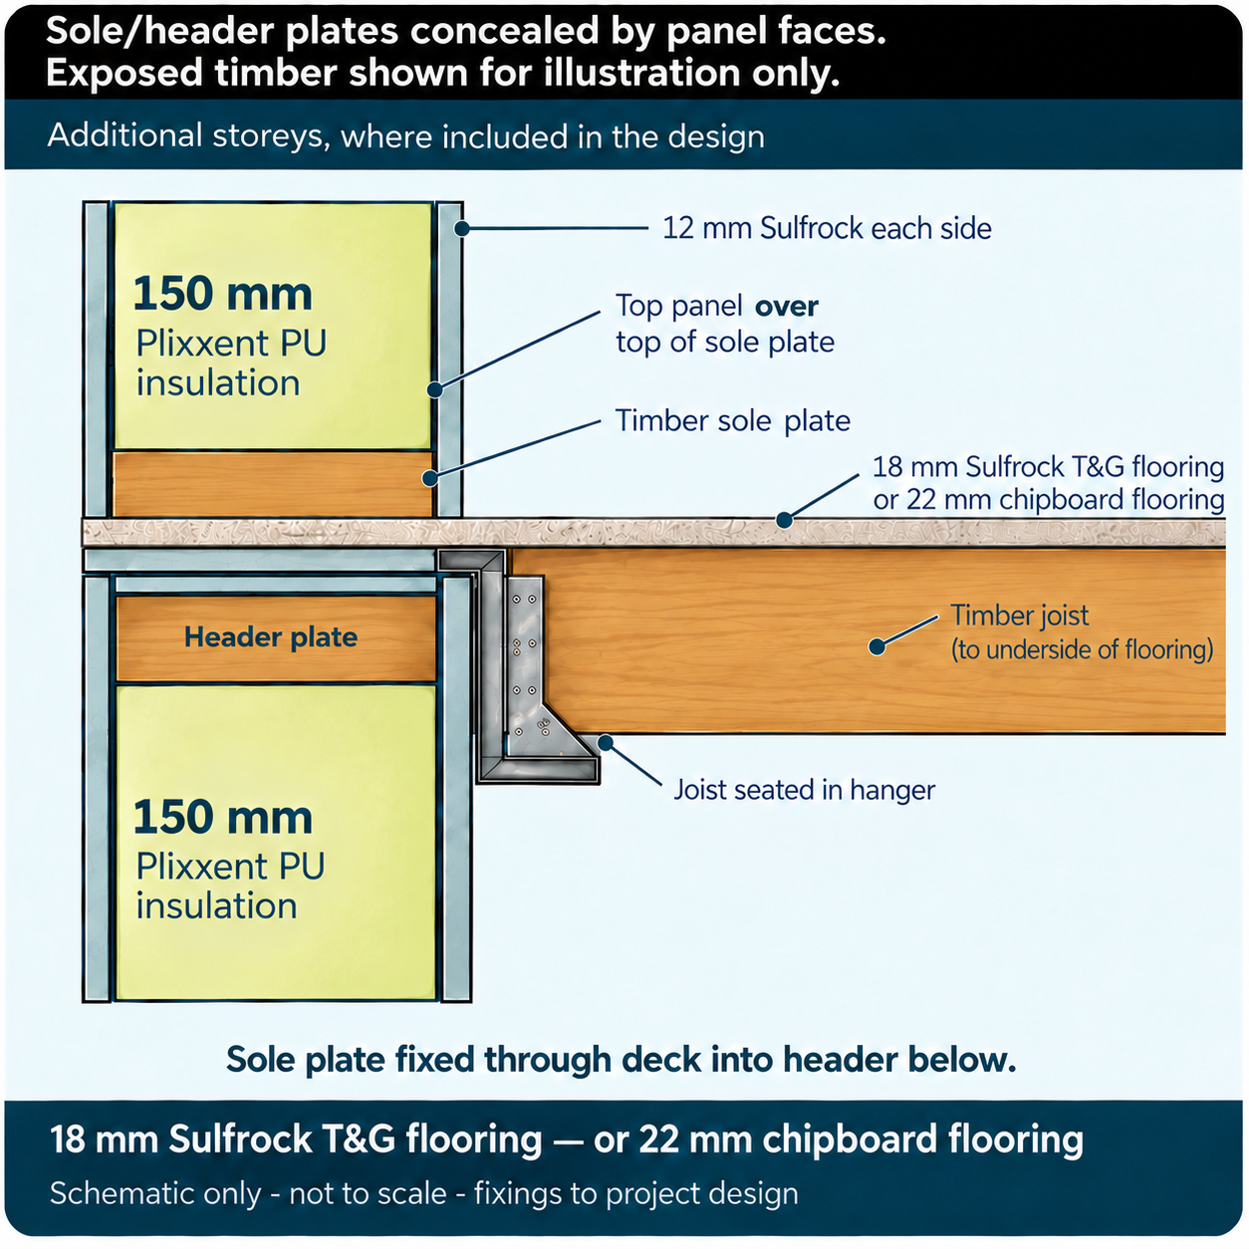
Flooring alternatives: 18 mm Sulfrock tongue-and-groove (T&G) flooring or 22 mm chipboard flooring. Manufacturer flooring certification is awaited and will be added following verification. Joist spans, loads, hangers and fixings follow the project structural design.

